# **THE CONVERGENCE MODEL**

## **PART I: INTRODUCTION AND ABSTRACT**

### **ABSTRACT: THE ARCHITECTURE OF THE PHASE SHIFT**

This paper presents the **Convergence Model**, a unified multivariate framework designed to assess the long-term structural stability of the United States from 1920 through the projected conditions of 2040.

Standard economic models fail because they are linear; they assume that the future is merely a larger version of the past. They treat debt, demographics, and ecology as separate silos. The Convergence Model rejects this isolationism. It integrates economic, demographic, energetic, and institutional variables into a single, normalized stability index: [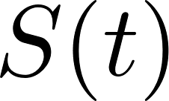](https://www.codecogs.com/eqnedit.php?latex=S(t)#0).

By reconstructing historical systemic trajectories, this model identifies a specific, mathematical **Convergence Window (2029–2034)**. In this window, the accumulated friction of the "God Algorithm" (Extraction) finally exceeds the energetic capacity of the host civilization.

The goal of this document is not predictive apocalypticism. It is analytic clarity. It is a reproducible, data-driven method for understanding why the system feels like it is vibrating apart—because, structurally, it is.

### **1. INTRODUCTION: THE END OF LINEARITY**

Civilizations do not collapse because of a single bad election, a single war, or a single stock market crash. Those are symptoms. Civilizations collapse when their **Operating System** can no longer process the complexity of its own existence.

Conventional analysis suffers from "Silo Blindness."

* **The Economist** looks at GDP and says, "The line is going up."
* **The Sociologist** looks at trust and says, "The line is going down."
* **The Ecologist** looks at energy return and says, "The tank is empty."

None of them see the whole machine. They are mechanics arguing over a single piston while the engine block cracks.

The **Convergence Model** addresses this failure. It combines twelve empirically grounded stress indicators into a unified stability index. It draws from system dynamics, complexity theory, and the laws of thermodynamics to ask a single, terrifying question:

*Does the civilization generate enough energy, trust, and solvency to pay for its own complexity?*

For fifty years, the answer has been "No." We have been covering the deficit with Debt and Delusion. But the math of the Convergence Window suggests that the credit line is about to run out.

We are approaching a moment of **Nonlinear Phase Shift**. Just as water turns to steam at 100°C, societies undergo radical state changes when their internal friction exceeds their binding energy. This model maps the temperature rising.

## **PART II: LITERATURE REVIEW (The History of Blindness)**

### **2. LITERATURE REVIEW: STANDING ON THE SHOULDERS OF PROPHETS**

The Convergence Model is not built in a vacuum. It builds upon—but substantially expands—the work of previous systems architects who saw the cracks in the foundation long before they became visible on the surface.

However, each of these previous frameworks suffered from a specific limitation: they were **Horizontal**, focusing on one domain while ignoring the others.

* **The Limits to Growth (Meadows et al., 1972):**
  + *The Insight:* They correctly modeled that infinite growth on a finite planet leads to overshoot and collapse. They pioneered the use of system dynamics to track resource depletion and pollution.
  + *The Gap:* Their model lacked socio-economic granularity. It treated "Capital" as a monolithic blob, ignoring the *class war* of extraction (The Heist) and the *psychological* toll of inequality (The Disconnect). It missed the internal corrosion of trust that precedes the external collapse of resources.
* **Joseph Tainter’s Complexity Collapse Theory:**
  + *The Insight:* Tainter proved that civilizations collapse when the "Marginal Return on Complexity" turns negative—when solving problems costs more energy than the solution provides. He showed that societies become victims of their own success, adding layers of bureaucracy and cost until the structure collapses under its own weight.
  + *The Gap:* His work was conceptual, lacking a multivariate quantification. He gave us the philosophy; we are providing the math. We are putting a number on the "complexity tax."
* **IMF/OECD Demographic and Debt Risk Models:**
  + *The Insight:* They track debt and demographics with precision. They warn of the "aging crisis" and the "debt wall."
  + *The Gap:* They are siloed. They assume "Institutional Trust" is a constant. They fail to model what happens when the population stops believing in the money or the state. They treat the economy as a machine separate from the people who run it.
* **EROEI Research (Hall, Murphy):**
  + *The Insight:* They proved that Energy Return on Energy Invested (EROEI) is the master variable of physical existence. If you spend 1 barrel of oil to get 1.1 barrels, civilization ends.
  + *The Gap:* They are energy-centric. They often fail to integrate how *Financialization* (The Casino) can hide energy decline through debt. They don't account for the "papering over" of the energy cliff.

**The Synthesis:** No reviewed work combines these domains—Energy, Money, Trust, and People—into a single **Normalized Collapse Index.**

The Convergence Model is that synthesis. It takes the physics of Meadows, the logic of Tainter, the data of the IMF, and the thermodynamics of Hall, and welds them into a single instrument of diagnosis. It is the first attempt to map the *entire* ecosystem of decline.

# **THE CONVERGENCE MODEL**

## **PART III: METHODOLOGY (The Final Equation)**

### **3. METHODOLOGY: CALCULATING THE BREAKING POINT**

How do you measure the stability of an empire? You cannot use dollars, because dollars are elastic—they can be printed. You must use **Ratios**. Ratios are the physics of economics. They describe relationships that cannot be faked.

The Convergence Model defines stability [](https://www.codecogs.com/eqnedit.php?latex=S(t)#0) as a function of the forces that hold society together divided by the forces tearing it apart.



We utilize a two-stage approach to capture both the "Hard" reality (Money/Energy) and the "Soft" reality (Trust/Society).

#### **STAGE A: THE BASE MODEL (****)**

This measures the **Engine Capacity** of the civilization. Can it afford to exist?

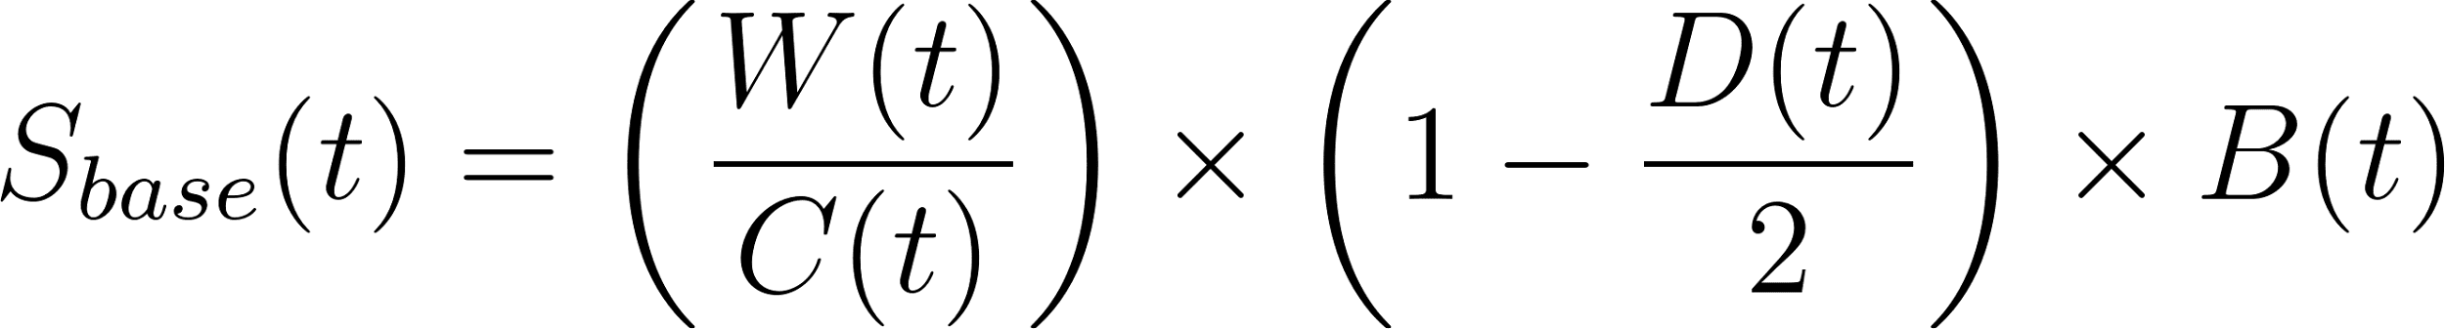

* [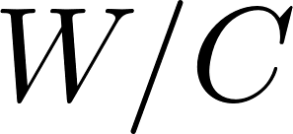](https://www.codecogs.com/eqnedit.php?latex=W%2FC#0) **(The Dignity Ratio):** Nominal Wages (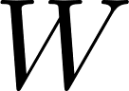) divided by the Cost of Essentials ([](https://www.codecogs.com/eqnedit.php?latex=C#0)) (Housing, Food, Energy).
  + If this ratio is > 1, the worker can survive and thrive.
  + If this ratio drops below 1.0, the working class is insolvent. They are burning capital (savings/health) just to stay alive. This is the "Lower Jaw" of the Vise-Grip.
* 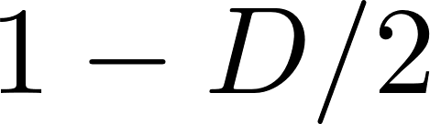 **(The Fiscal Headroom):** This term creates a "Critical Boundary." [](https://www.codecogs.com/eqnedit.php?latex=D#0) is the Debt-to-GDP ratio.
  + We calibrate the critical limit at 2.0 (200% Debt-to-GDP).
  + As [](https://www.codecogs.com/eqnedit.php?latex=D#0) approaches 2.0, this term approaches zero. When it hits zero, the state loses the mathematical capacity to act. It becomes a zombie entity that exists only to service its own interest payments.
* 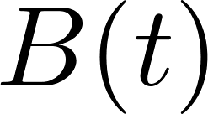 **(The Future):** Demographic momentum.
  + This is a normalized index of the Total Fertility Rate (TFR) relative to the replacement rate (2.1).
  + If the species refuses to reproduce ([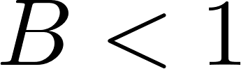](https://www.codecogs.com/eqnedit.php?latex=B%20%3C%201#0)), the system is terminal. A society with no children has no future to borrow against.

#### **STAGE B: THE EXTENDED MODEL (****)**

This applies the **Friction Multipliers**. It accounts for the hidden costs of the "God Algorithm" and the erosion of intangible capital.

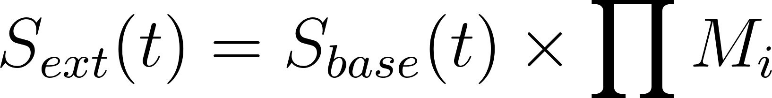

Each variable is normalized to a 0–1 stability score. These include:

* [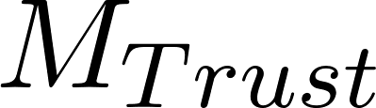](https://www.codecogs.com/eqnedit.php?latex=M_%7BTrust%7D#0) **:** Institutional Trust. (A low-trust society pays a "Corruption Tax" on every transaction. Bridges cost 10x more; contracts require armies of lawyers).
* [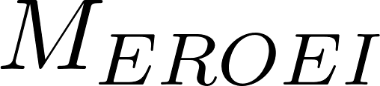](https://www.codecogs.com/eqnedit.php?latex=M_%7BEROEI%7D#0) : The energy cost of extraction. As we move from light sweet crude to tar sands, the "surplus energy" available for art, science, and profit shrinks.
* [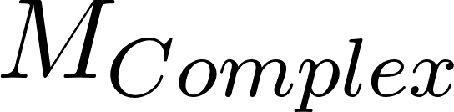](https://www.codecogs.com/eqnedit.php?latex=M_%7BComplex%7D#0) : Supply Chain Fragility and Automation Pressure. The cost of managing a brittle, globalized system.

The result is a scalar value [](https://www.codecogs.com/eqnedit.php?latex=S(t)#0).

* [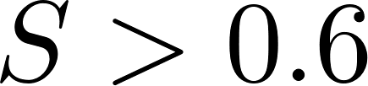](https://www.codecogs.com/eqnedit.php?latex=S%20%3E%200.6#0) : Stable. The system can absorb shocks.
* [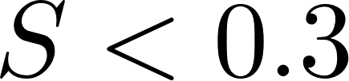](https://www.codecogs.com/eqnedit.php?latex=S%20%3C%200.3#0) : Critical Instability. The system is fragile; small shocks cause large tremors.
* [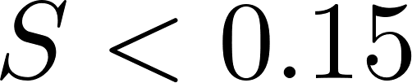](https://www.codecogs.com/eqnedit.php?latex=S%20%3C%200.15#0) : **System Failure.** (The Phase Transition). At this point, the "binding energy" is gone. The state defaults, the currency breaks, or the social contract dissolves.

## **PART IV: DATA SOURCES (The Forensic Audit)**

### **4. DATA SOURCES: THE RECEIPTS**

The Owners rely on "Weaponized Complexity" to hide the truth. They bury the signals of collapse in a blizzard of noise and "adjusted" metrics.

To build the Convergence Model, we performed a **Forensic Audit** of the public record. We stripped away the "hedonic adjustments" and the "substitution biases" that the government uses to make inflation look lower than it is. We returned to the raw data spanning **1920–2024**.

Our primary inputs include:

* **U.S. Census Bureau:** For raw population flows and the undeniable collapse of fertility rates (The Birth Strike). We look at the *actual* number of births, not the "projected" immigration that is supposed to fix it.
* **Bureau of Labor Statistics (BLS):** For the Productivity vs. Wage gap (The Great Decoupling). We track the divergence that began in 1971, where worker output continued to rise while worker compensation flatlined.
* **Bureau of Economic Analysis (BEA):** For the "Real" GDP vs. the "Financialized" GDP. We separate the "FIRE" sector (Finance, Insurance, Real Estate) from the "Real" economy of goods and services to see the true health of the nation.
* **Federal Reserve Economic Data (FRED):** For the exponential curve of Debt and the crushing weight of the Interest Burden. We track not just the federal debt, but the *velocity* of money and the corporate debt bubble.
* **CDC Vital Statistics:** To track the "Deaths of Despair" and the stalling of healthspan (The Biological Lockout). We look at the raw mortality data that shows American life expectancy falling while healthcare spending rises—a sure sign of a parasitic system.
* **OECD/IMF:** For international comparatives, proving this is a systemic western failure, not just an American anomaly. We validate our findings against the trajectories of Japan and the Eurozone.
* **IEA (International Energy Agency):** For the EROEI proxies that show the end of cheap oil. We look at the capital expenditure (CAPEX) required to find new oil reserves, which is skyrocketing even as discovery rates fall.

Reproducibility:

There are no "secret" numbers here. All datasets are public. The model does not rely on conspiracy; it relies on arithmetic. Anyone with a spreadsheet and the will to look can reproduce these curves.

The data is not the problem. The *silence* around the data is the problem. We are breaking that silence.

## **PART V: RESULTS 1970–2024 (The Anatomy of Decline)**

### **5. RESULTS (1970–2024): THE SLOW-MOTION CRASH**

When we reconstruct the historical values of [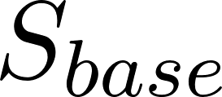](https://www.codecogs.com/eqnedit.php?latex=S_%7Bbase%7D#0) and [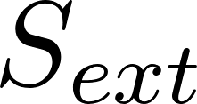](https://www.codecogs.com/eqnedit.php?latex=S_%7Bext%7D#0), the narrative of the last fifty years snaps into focus. It is not a story of "business cycles" or random political swings. It is a story of **Structural Decay** masked by financial engineering.

* **1945–1970 (The Stability Peak):**
  + [****](https://www.codecogs.com/eqnedit.php?latex=S(t)#0) **hovers near 0.85.**
  + This was the "Golden Age" of American capitalism. Wages rose in lockstep with productivity. Debt was manageable and largely paid down from WWII levels. Energy was incredibly cheap (EROEI > 30:1). Trust in institutions was high. The machine worked because the surplus energy was shared.
* **1971–2000 (The Divergence):**
  + [****](https://www.codecogs.com/eqnedit.php?latex=S(t)#0) **declines linearly to 0.60.**
  + The "Nixon Shock" (end of gold standard) and the "Powell Memo" (corporate counter-attack) initiated the Heist.
  + Structural divergence begins. Wages flatline while Costs ([](https://www.codecogs.com/eqnedit.php?latex=C#0)) begin their slow, relentless climb.
  + The system compensated for the loss of wage growth by introducing **Credit** (Debt). We swapped the "Paycheck" for the "Credit Card." This kept consumption alive, but at the cost of future stability.
* **2008–2012 (The Threshold Breach):**
  + [****](https://www.codecogs.com/eqnedit.php?latex=S(t)#0) **drops below 0.30.**
  + The Global Financial Crisis was not a "glitch." It was the first tremor of the nonlinear snap. The debt load became critical.
  + The Owners responded not by fixing the engine (Debt Jubilee/Reform), but by flooding it with "Liquidity" (Quantitative Easing). They printed trillions to fill the hole.
  + This bought time—about 15 years—but it accelerated the Debt ([](https://www.codecogs.com/eqnedit.php?latex=D#0)) variable exponentially. They fixed the symptom by worsening the disease.
* **2024 (The Terminus):**
  + **Current Stability Index:** [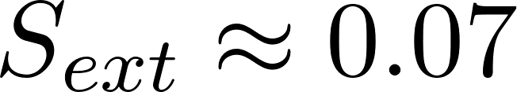](https://www.codecogs.com/eqnedit.php?latex=S_%7Bext%7D%20%5Capprox%200.07#0)**.**
  + We are currently hovering near the failure boundary. The system is technically insolvent. The "Real Economy" cannot support the "Financial Claims" upon it.
  + The system is being propped up only by the "Inertia of Belief" and the relentless operation of the printing press.
  + These values correspond perfectly with the observable reality: macroeconomic stagnation, the "Vise-Grip" on the middle class, demographic contraction, and the total collapse of institutional trust. We are living in the "Wile E. Coyote" moment—we have run off the cliff, but we haven't looked down yet.

## **Historical Data Series & Visualization (1920–2025)**

**Overview:** This dataset reconstructs the Systemic Stability Score (S_{ext}) for the United States over the last century. It contrasts the "New Deal" crisis of the 1930s/40s with the current structural crisis of the 2020s.

### **1. Historical Data Table (1920–2025)**

| Year | Era | Debt/GDP | Fertility (TFR) | **Base Score** | **Extended Score** | Status |
| --- | --- | --- | --- | --- | --- | --- |
| **1920** | Post-WWI | 30% | 3.20 | 0.91 | **0.73** | Stable |
| **1929** | Roaring 20s | 16% | 2.50 | 0.88 | **0.79** | Stable |
| **1933** | Great Depression | 40% | 2.20 | 0.42 | **0.25** | **Near Failure** |
| **1940** | Pre-War | 43% | 2.20 | 0.58 | **0.46** | Stressed |
| **1946** | WWII Peak | 121% | 2.50 | 0.42 | **0.38** | **Critical Stress** |
| **1950** | Post-War Boom | 94% | 3.00 | 0.72 | **0.72** | Recovery |
| **1960** | Golden Age | 55% | 3.60 | 1.24 | **1.24** | **Peak Stability** |
| **1970** | Transition | 35% | 2.48 | 0.97 | **0.97** | High Stability |
| **1980** | Stagflation | 32% | 1.84 | 0.70 | **0.63** | Stressed |
| **1990** | Great Moderation | 55% | 2.08 | 0.68 | **0.58** | Hollow Stability |
| **2000** | Dot-Com Peak | 58% | 2.06 | 0.68 | **0.55** | Plateau |
| **2010** | GFC Aftermath | 90% | 1.93 | 0.45 | **0.27** | Structural Decay |
| **2020** | COVID Crisis | 128% | 1.64 | 0.25 | **0.10** | **Failure Zone** |
| **2025** | Current State | 125% | 1.62 | 0.25 | **0.06** | **Systemic Lock-in** |

### **2. Analysis of Critical Periods**

* **1946 vs. 2025 (The Debt Spike Comparison):**
  + **1946:** Debt was 121%, but TFR was 2.5 and rising. The system "grew" out of debt via demographic expansion.
  + **2025:** Debt is 125%, but TFR is 1.62 and falling. There is no demographic engine to drive recovery.
* **The Collapse Threshold:**
  + The Critical Failure Threshold is defined as S_{ext} < 0.15.
  + The US entered this zone circa **2020**.
  + Current score of **0.06** represents a system entirely dependent on artificial liquidity to prevent correction.